NIKITA CHOUDHARY

ROLL NO. – 1901610100125

AIM: Write a c program to perform insertion sort

Program-

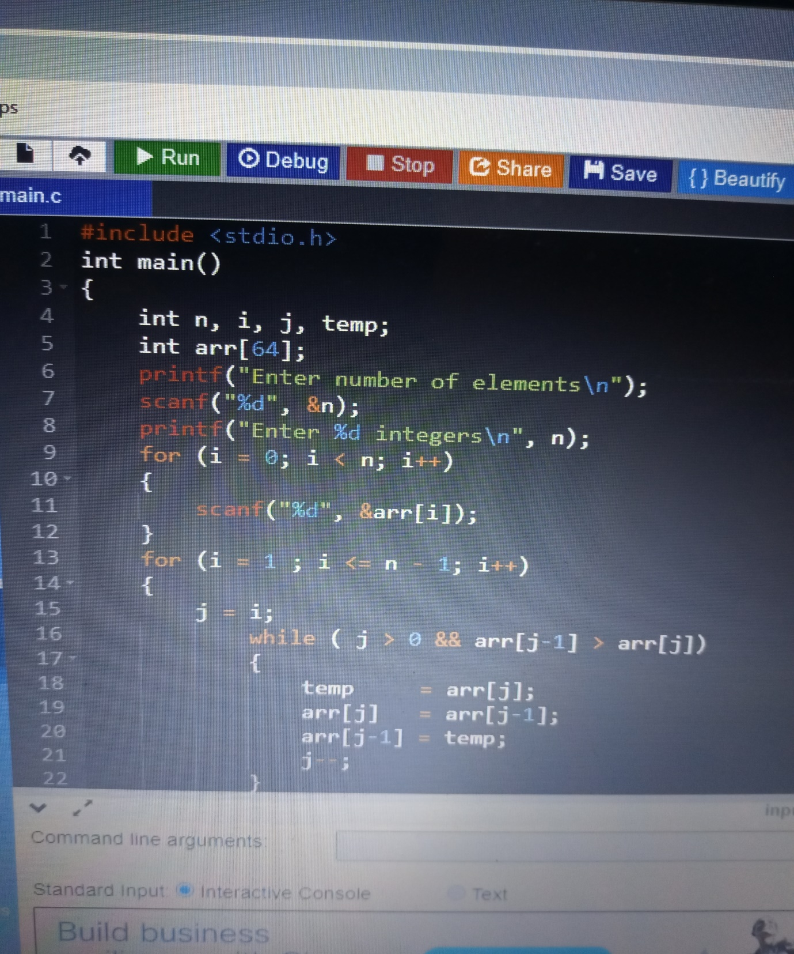

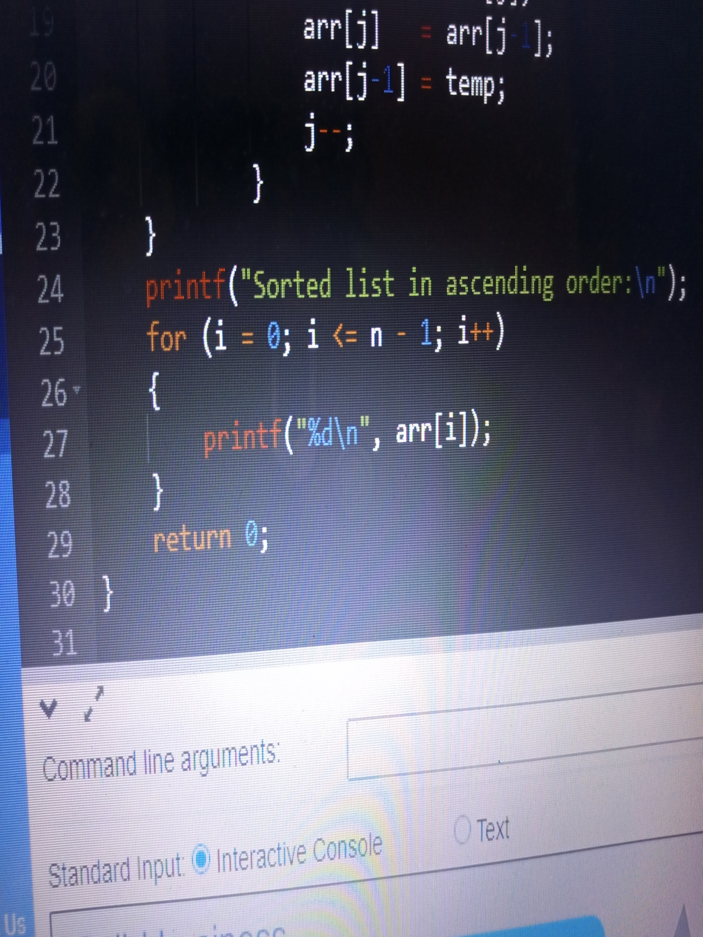

Output-

